UI Health – Digital Transformation during COVID-19

Skandan Ganesh,[Meghashree Maddihally Nagoji](mailto:mmaddi2@uic.edu)**,** [Sai Hruthik Reddy Varakantham](mailto:svarak3@uic.edu)**,** [Raina Miriam Jose](mailto:rjose21@uic.edu)

**Abstract**

**Background**

The COVID-19 pandemic has set a new normal across the globe. The dynamics of living, business, and communication have drastically changed. Hospitals have been at the forefront of this change, not only with treating the coronavirus patients whilst taking control measures to contain the spread of the virus, but also to adapt to new digital pathways to continue regular physician services and vaccinations.

**Objective**

To understand the role of Information Technology (IT) in digital transformation at UI Health during the COVID-19 pandemic period.

**Methods**

The study reported here used personal interviews with the Information Systems team including the CIO, the Director of Information Systems & the Business Intelligence team (lab reporting executive, vaccination reporting executive, electronic doctor records executive, and BI analysts and developers). The data was gathered from hospital records and in-persons visits.

**Results & Findings**

The Electronic Medical Record (EMR) migration planned by UI Health enabled them to better prepare for the new normal set by the COVID-19 pandemic. The features of the new EMR system (EPIC) consolidated all applications and billing systems, leading to a massive consolidation of physicians, patient medical records, and other data. It helped them respond to service requests in a more timely and efficient manner. Digital health has opened more avenues for UI Health to connect with patients in a more cost-effective way.

**Conclusions**

Strong digital and IT infrastructure is essential for preparing an organization for unforeseen circumstances. Information Technology also leads to higher operational optimization and opens more avenues for spanning new businesses. Futuristic leadership vision is required to drive such organizational changes. However, digital solutions also give rise to barriers to adoption, which need to be planned while designing solutions.

Table of Contents

Introduction 3

December 2019 3

March 2020 & Beyond 3

Approach 3

Healthcare Industry Post COVID-19 4

UI Health: Pre COVID-19 Times 4

Pre-Deployment of EPIC 4

UI Health: Post COVID-19 Times 5

First COVID-19 Patient Admission and Next Steps 5

Organizational Changes 5

Cancellation of Planned Surgeries & Ambulatory Services 6

Internal Updates and Communications 6

External Communication & Regulatory Metrics 6

IT Changes 6

Emergency Around COVID-19 Service Requests 6

e-Consults 6

EPIC Go-Live 7

Factors Hindering the IT Transformations 8

Other Trends 8

Vision for the Future 9

Learnings 9

Exhibits 11

References 16

Abbreviations 17

# Introduction

## December 2019

After patient zero of the coronavirus was confirmed in the Wuhan region of China on December 30, 2019, a media announcement for a possibility of person-to-person transmission was made on January 21, 2020 **12**), and the city of Wuhan was put under lockdown. Since the COVID-19 virus was suspected to be transmitted through aerosols from infector to infected, a series of events trickled down the world which included research of the COVID-19 virus, saliva testing, travel restrictions, new social norms including social distancing, lockdowns, and much more.

Hospitals across the globe responded to the coronavirus through a series of iterative steps to treat the coronavirus patients **3)** **4)**, including but not limited to, creating a separate physical facility for COVID-19 patients to contain contamination, releasing communication to the public regarding the coronavirus, introducing protective gear to protect the healthcare providers, and leveraging Information Technology to develop digital ways to connect the patients to the healthcare providers. Hospitals across the world experienced massive collaboration to initiate and adopt newer ways to fight the pandemic. Innovative digital solutions were introduced to screen patients for COVID-19 symptoms before the hospital visit. The same was adopted by other places as well, such as offices, malls, and smaller clinics.

## March 2020 & Beyond

The University of Illinois Hospital & Health Sciences System (UI Health) **13)** situated in Chicago provides comprehensive medical care, education, and research. Like any hospital, the Information Systems at UI health utilized an Electronic Medical Record (EMR) system, Cerner. With the rising need for the latest healthcare technology and inefficiencies of the existing EMR system, a project was initiated and a planned switch to the new EMR system, EPIC, was scheduled in March 2020. On March 12, 2020, UI Health admitted their first coronavirus patient and with the rising coronavirus cases and hospitals being under the massive pressure of treating coronavirus patients, while containing the spread of the virus, the leadership at UI Health decided to postpone the Go-Live of EPIC to September 12, 2020. While this may have brought down the spirits of the staff members who had been working for two years to prepare for the switch-over, according to a senior executive at UI Health, it was a boon in disguise. This time was utilized in updating & testing the system with recent patches which were in line with the digital health requirements for the new normal set by the COVID-19 pandemic.

# Approach

In our study, we interviewed the top executives of the Information Technology department and the business intelligence team to understand the transition in terms of work deliverables from pre COVID-19 to post COVID-19 times, new EMR system, and understand the future vision of digital healthcare **(Exhibit 1).**

These interviews were conducted at UI Health and few were conducted online. Additionally, various online journals **2)** were referred to understand how healthcare institutions adopted technology to suit the needs during the pandemic.

# Healthcare Industry Post COVID-19

Hospitals in China **1)** responded quickly to the pandemic by changing the physical layout for outpatients and opened new digital channels (social media & websites) for the population to book online appointments. Guangdong Provincial People’s Hospital introduced two robotic employees to deliver medicines within the hospital to nursing stations/isolation wards. Applications such as WeChat were adopted to set up groups with providers and patients for audio & video communication. COVID-19 centric training for healthcare providers was conducted online. Many hospitals in China launched their online consultation services to respond to the pandemic.

A hospital in Germany **11**), adhering to the new social distancing norms and to ensure patient care, adopted MS Teams as the video conferencing tool to enable collaboration, communication & file sharing among providers.

Hospitals noticed reduced out-patient footfall and to continue to provide physician access to patients, healthcare institutes adopted IT measures to develop telemedicine platforms and to develop no-contact screening of patients to contain the spread of the coronavirus. In addition, several training and communication regarding COVID-19 preventive measures for the public were conducted through digital solutions.

# UI Health: Pre COVID-19 Times

## Pre-Deployment of EPIC

UI Health was operating on systems that were purchased in the early 90s, an EMR system (Cerner) that had different interfaces (approx.30), two different billing systems, and several other applications which were not integrated. The business intelligence team would work with the physicians and other end-users to understand their data needs and build relevant reports and dashboards within a defined turnaround time. Medical records and other data were distributed between multiple systems and required consolidation for better patient view and operational efficiency.

To address this problem, Dr.Ghosh (ex-Dean at University of Illinois Urbana Champaign) was onboarded as the CEO of UI Health to spearhead a “generational”, $160M project called 3I (short for Integrated Information Infrastructure) **14)**, earlier named as ESI (Enterprise System Integration), which was intended to integrate and optimize business processes with standardized clinical workflows and analytical research capabilities. Dr.Ghosh was convinced that UI Health cannot be the organization it wants to become with the legacy systems. The project was projected as a “transformational” project and not an IT project.

The goal of the project was to transform and combine the existing Electronic Medical Record (EMR) systems and the two billing systems into one. The approach which was followed involved:

1. Clean up in the backend of the billing system (untangling of data took ~2 years).
2. Integration of all the existing applications into one system.

In this process UI Health faced many challenges:

1. Seeking approval from the management of UI Health for the enormous investment required for the project.
2. Onboarding the human resource skilled in that technology was hard, as the technology was dated.

Digital vendors (four in number) with a team of approximately 100 employees were onboarded for the successful migration of the EMR system. The decided time to Go-Live with the new EMR system (EPIC) was March 2020. According to a senior IT executive “All *the possible project completion risks were thought of and listed; however, a pandemic was not one of them*”.

# UI Health: Post COVID-19 Times

## First COVID-19 Patient Admission and Next Steps

On 12 March 2020, UI Health admitted its first coronavirus patient. A meeting including the CIO of UI Health along with 120 executives was conducted to formulate a plan for the Go-Live of the new EMR system. Observing the rising coronavirus cases coupled with the new stay-at-home orders passed in the state of Illinois, the management at UI Health decided to postpone the Go-Live to 12 September 2020 and UI Health declared a state of emergency.

UI Health predominantly worked in three directions:

1: COVID-19: Patients, Vaccinations, Contact tracing

2: Restoring doctor consultations through digital solutions, such as Telemedicine.

3: Migration to EPIC and leveraging its features to expand healthcare facilities & reporting

# Organizational Changes

Command Center Approach

The Institute adopted a ‘*command center*’ approach & moved forward with quick ‘imperfect’ decisions. Starting 15 March 2020, a separate facility was created inside UI Health to treat COVID-19 patients.

“*We had to re-establish the chain of commands; daily command center touch base determined daily routines*”.

## Cancellation of Planned Surgeries & Ambulatory Services

To avoid virus contamination and increase focus on COVID-19, all non-essential ambulatory services were canceled.

## Internal Updates and Communications

The business intelligence (BI) team which primarily provided operational metrics to its users, after the dawn of the pandemic, sent daily email updates thrice a day to the leadership including the CEO, CIO, COO, Chief Quality Officer, Chief Nursing Officer & Chief Medical Officer. The email contained the COVID-19 patient status, bed availability status, ventilator status & associated trends. All non-COVID studies got shut down, planned surgeries were canceled and COVID-19 was tackled ‘*All hands-on Deck*’.

## External Communication & Regulatory Metrics

As per federal guidelines on regulatory metrics, UI Health provided regular data updates to the Illinois Department of Public Health (IDPH) & the Chicago Department of Public Health (CDPH). These metrics were primarily regarding bed availability, COVID-19 patients, recovery rate, mortality rate, and ventilator availability.

# IT Changes

## Emergency Around COVID-19 Service Requests

All requests related to COVID-19, such as reports, enhancements, and metrics were given higher priority. Changes were implemented within hours in comparison to a normal turnaround time of weeks. These requests could be around the reports for the number of patients on ventilators, new functionality, the average length of stay, and medicine details. Business users requesting IT for any non-COVID requests were understanding towards the high turn-around time. This emergency was well acknowledged by UI Health as well as by their digital vendors, who provided quick solutions to change requests and did not bill UI Health for any change requests. This policy was adopted by both the EMR vendors (Cerner and EPIC).

“*We practiced emergencies, there were protocols as soldiers, we would carry out instructions*”.

## e-Consults

Telehealth and e-prescriptions were existing channels for UI Health. Tele-conferencing tools such as Zoom & MS Teams were purchased by the institute to facilitate provider-patient communications. As per the data observed, the virtual appointments dropped by 60%, as people were not falling sick as often due to home quarantine. The virtual appointments were moved to the new EMR system (EPIC) after September 2020.

## EPIC Go-Live

After years of hard work and enormous rounds of testing, the EPIC EMR system was launched at UI Health on September 12, 2020. Special consultants were hired and assigned to providers to help them seamlessly provide patient care through the new telehealth platform. Elbow-support was provided by EPIC to ensure smooth adoption and easy switch over to the EMR system, without compromising patient care.

Patients’ adoption of telehealth spiked after COVID-19. This could be a result of preventive measures by patients to avoid contamination caused by hospital visits and to also save travel time. Patients were provided with a personalized space inside the application (MyChart) which contains all their past and future appointments, primary physician information, prescriptions, and vaccination information. New developments on EPIC were introduced based on situational requirements.

“*We immediately launched new programs in EPIC, which we just went live with, typically you give it some time for the new system to stabilize, we were doing that but also new things*”.

Contact Tracing

EPIC was utilized for contact tracing, which essentially facilitated finding all the people who were in contact with the infected people, enabling preemptive measures to control the spread of the virus.

Vaccinations

As soon as the vaccination doses were received by UI Health, EPIC was configured to the needs of the vaccination drive **15)**. UI Health, UIC, and UI Police all worked together to make the drive a success. Targeted emails and text messages were sent to the registered patients of UI Health based on specific segmentation to boost immunization. The vaccination was planned to be rolled out on a tiered basis, which had tiers such as healthcare workers, comorbid conditions, age, etc. The slot booking for vaccinations could only appeal to the tech-savvy audience and to overcome this impediment, ‘Project SUPPORT’ was launched **16**). This project enrolled volunteers, who were provided with calling applications on the phone (such as Cisco jabber) and online training, to initiate outbound calls to the patients to book their vaccination slots (**Exhibit** **2).**

An EPIC-enabled tabular dashboard displayed total vaccinations (**Exhibit 3**) which were administered. These were further segregated based on the first dose and second dose (**Exhibit 3a**).

In addition, heat areas were determined based on the vaccinated population by area, which was achieved using Tableau.

“*We went from the response, to operationalizing to wide-scale testing with technological advancements*”.

Open Scheduling

As a measure to attract more vaccination walk-ins from the unregistered population, vaccination slots were published online on the website for the population to enter basic information and book an appointment. This became the most popular vaccination channel to the hospital. The open scheduling link was shared using social media, which helped UI Health achieve the coverage required for vaccinations.

Additionally, vaccination requests could be placed on the MyChart profile by a provider for high-risk patients. Once the request was placed, the patient would receive a notification. This activity fueled more voluntary vaccination walk-ins and helped immunize the high-risk patients of UI Health. Approximately 150,000 doses were administered in total.

IT Infrastructure for Triage Tents

The Information Systems team at UI Health extended the IT infrastructure for the triage tents where the patients were screened for COVID-19 and all the information was sent as an input to the EMR system.

# Factors Hindering the IT Transformations

1. Work from home policy

Like any healthcare institution, UI Health operated within a traditional on-site work environment, and with the new stay-at-home orders passed by the Governor of the state of Illinois, the Information Systems (IS) team was asked to work from home. The training of the healthcare providers and the end-users of the to-be EMR system (EPIC) was moved online. It came with its challenges of low engagement from the trainees. According to a senior executive “*Morning stand-up meetings were virtual, and as it was taking a toll on the mental health of the employees, it was imperative to include healthy conversations to keep the spirits up*”.

1. The virus spread among staff members

According to a senior IT executive at UI Health, few of the staff members contracted the virus which thwarted the project progress.

1. Lack of digital adoption from providers who prefer in-person patient administration

Many physicians preferred to check the patients in-person, as it required physical contact which could not be replaced by digital solutions.

1. Lack of adoption of digital health by the aged population

Many aged individuals (>60 years) were not comfortable adopting digital health solutions and in turn, digital became a barrier to providing healthcare to them.

1. Webcam burnout was being experienced by the hospital clinicians.

“*Post-COVID*, *we started focusing on digital well-being*”.

# Other Trends

Amidst the pandemic, UI Health observed trends across its services and departments:

1. Possible revenue drops due to cancellation of ambulatory services: There were high cancellations of planned surgeries to avoid hospital visits and virus contamination (**Exhibit 4, 5 & 6**). As a result of this, there could have been a drop in revenue.
2. Adoption of telehealth: To continue doctor consultations and avoid hospital visits, there was a quick adoption of telehealth by the patients and the providers (**Exhibit 7**).
3. The shelf life of pharmacies increased: Many popular pharmacies experienced a longer shelf life due to decreased hospital footfall.
4. Insurance issues were on the rise due to unemployment during the pandemic: As cost- cutting measures were adopted by employers to cope up with the pandemic, many lost their jobs and their insurance cover.
5. Reporting Metrics: The focus of reporting changed after COVID-19. Before COVID-19, the reports would primarily focus on bed availability, OPD visits, ICU patients, and other operational metrics. After COVID-19, the metrics around coronavirus patients took precedence. These included COVID-19 patient admissions, recovery, mortality, vaccinations status by ethnicity and area, comorbidities, ventilator status, and testing.

Additionally, reports went through two changes, it became patient-specific and provider- specific. Reports focused on the patient’s self-assessment and symptoms check, which were recorded before their first encounter at the hospital.

# Vision for the Future

There were tangible goals envisioned before the transition to the new EMR system. However, after the pandemic, the management at UI Health believes that the decision of making this change could not have been timed any better. It provided the necessary support to provide online healthcare, contain the virus spread, execute vaccinations in a phased manner, extract data based on the various metrics and consolidate various applications to create a one-stop for all health information.

In our interviews, we noticed a positive response from the business intelligence team for the new EMR system, as the new reports and dashboards could now be extracted much quicker than the previous one.

The senior management of Information Systems has embraced the new change in the EMR system and is positive about the future digital health holds.

*“Digital health is here to stay”*

On the other hand, a senior executive, in our conversation with him, mentioned that digital solutions, while creating new avenues for healthcare, also create new barriers for the population which is not comfortable with technology and alternative methods to address this issue should also be taken into consideration.

*“ We are creating solutions, yet we are creating another barrier for folks that can’t really access them, so we have to watch out for these barriers while rolling out these solutions”*

# Learnings

As technology is a rapidly growing domain and for industry professionals, it is imperative to continue to adopt and grow with the latest technology, thus for ‘generational’ projects, which happen once in two decades, identification of specialized human resources for dated technologies creates a barrier for system migration.

Digital solutions are being rapidly adopted by companies across all industries. However, the design principle around products should account for easy adoption by non-tech-savvy users as well. Solutions should not become barriers.

Users of digital solutions (telehealth in this case) can experience burnout, like how physicians at UI Health did. There are not enough solutions to tackle this problem. However, this can become a pressing problem for the adoption of digital solutions.

‘Generational’ or ‘transformational’ projects often involve huge costs, therefore, a futuristic vision from the leadership is required to envision, invest, and execute such projects. The value of digital needs to be realized by the management and such projects should be treated as ‘transformational’ projects rather than IT projects. Strong IT infrastructure can enable businesses to prepare themselves for uncertain situations, such as a pandemic. Realizing the increased productivity and increased profits due to remote work, many organizations have adopted this as the new way to work, COVID-19 has unleashed new digital ways of working, collaborating, and conducting business.

# Exhibits

Exhibit 1: Interview Details

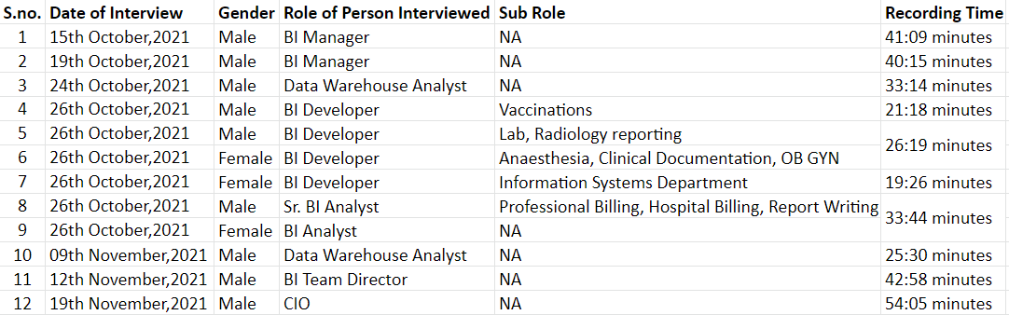

Exhibit 2: Project SUPPORT workflow

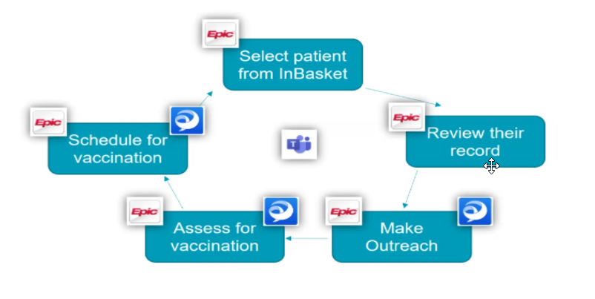

Source: <https://uihealth.uic.edu/ui-health-project-support/>

Exhibit 3: 2021 COVID-19 immunization administration graph

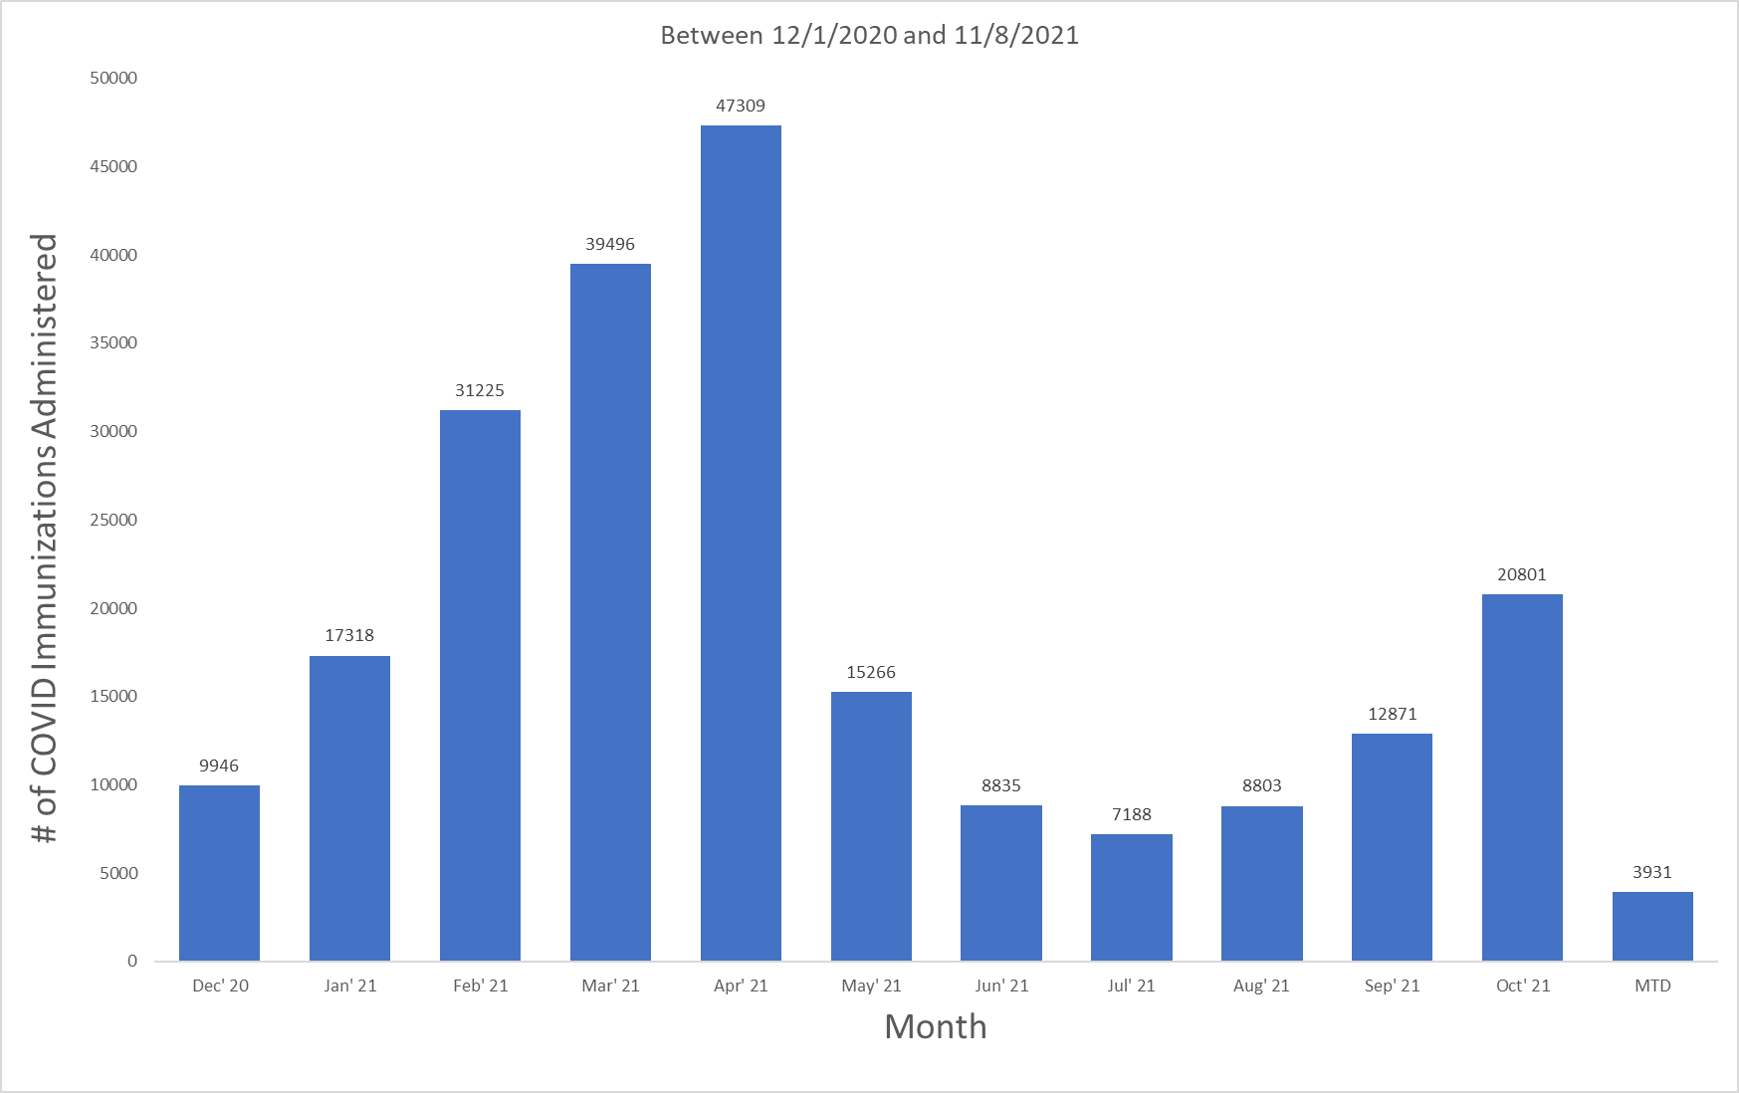

Source: Internal company records

Exhibit 3a: Immunization administration graph, bifurcated by first dose and second dose

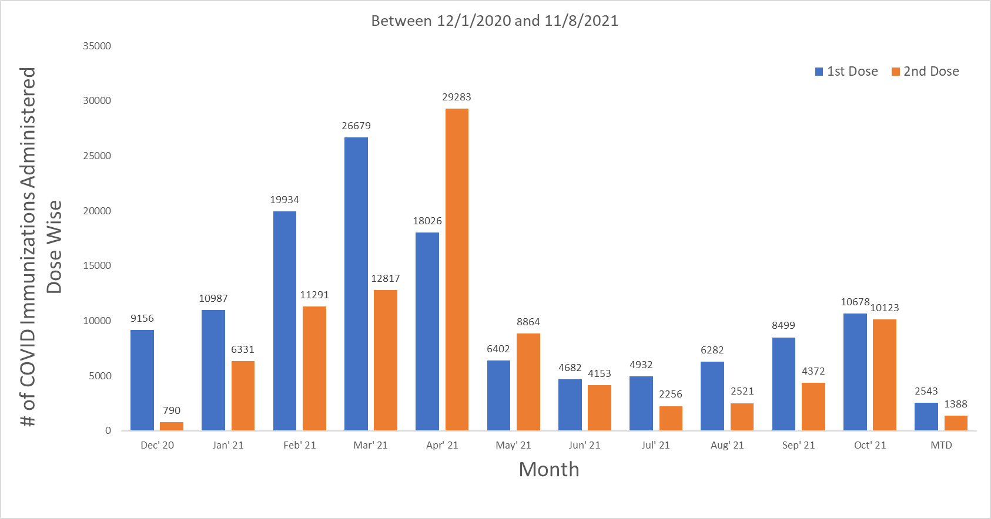

Source: Internal company records

Exhibit 4: COVID-19 impact on ambulatory visits at UI Health (Year 2020)

*The number of appointments for the day from February 17th till June 12th, excluding NO SHOW appointments.*

*On 17th June there were 1945 visits, which is the highest since the COVID-19 drop.*

*On average there used to be 2400-2500+ appointments per day at UI Health ambulatory locations. (excluding Mile square)*

*The drop in the number of appointments could be observed as COVID-19 became an issue in Chicago.*

*The many weekly drops are for Saturdays. Very few clinics are open on Saturdays to see patients.*

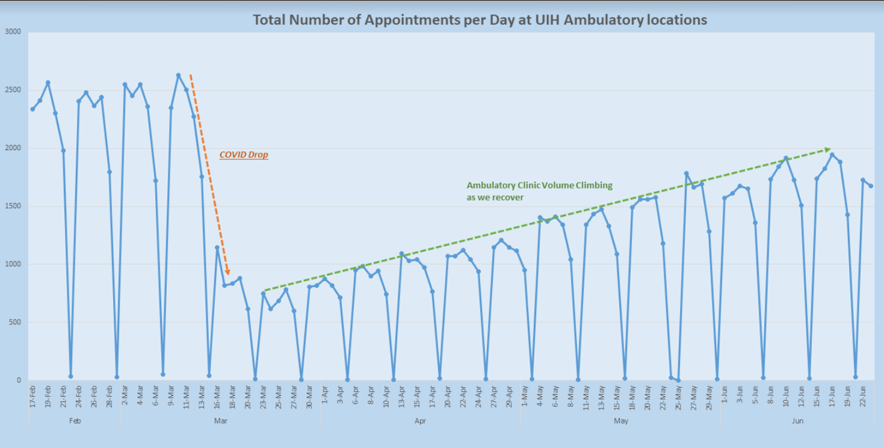

Source: Internal company records

Exhibit 5: Decline in the number of inpatient admissions (Year 2020)

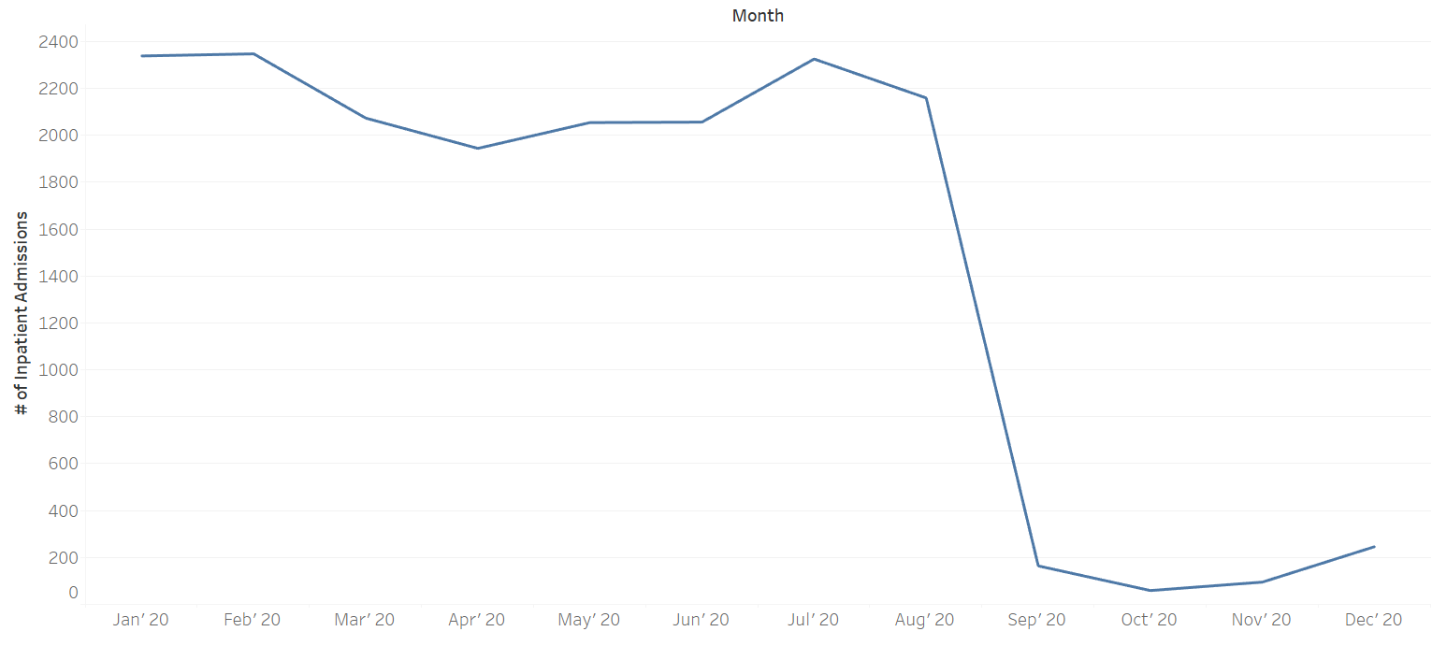

Source: Internal company records

Exhibit 6: Decline in the number of in-person visits (Year 2020)

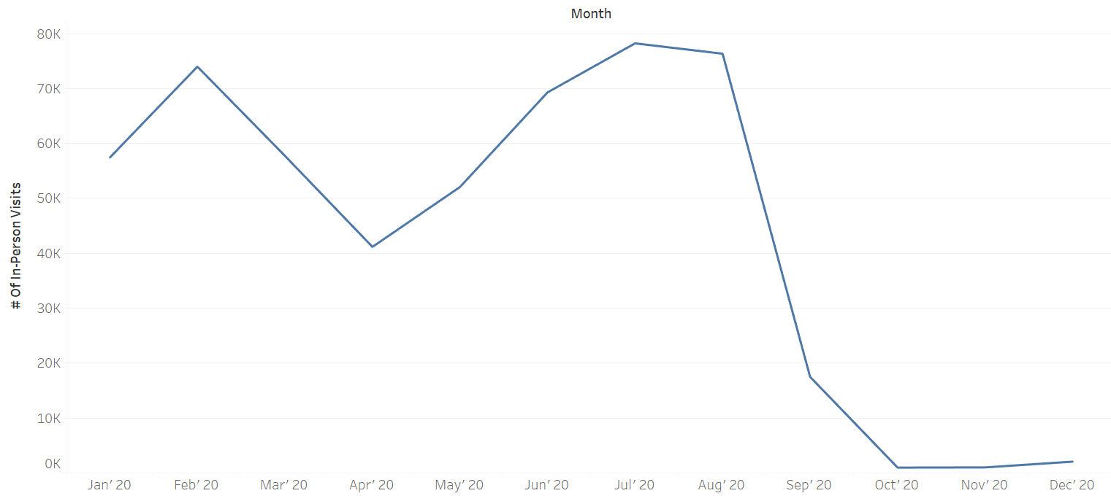

Source: Internal company records

Exhibit 7: Number of tele visits after going live in September

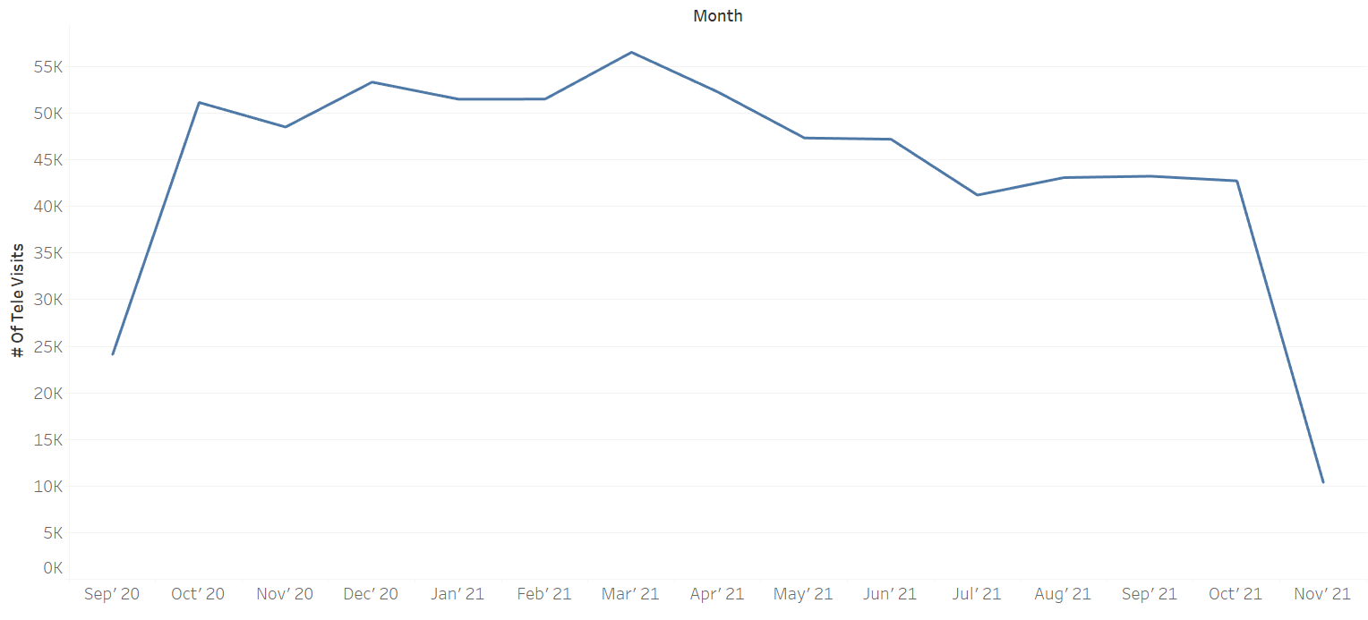

Source: Internal company records

Exhibit 8: KPIs shared with UI Health for reports

1. Number of tele visits before COVID-19 and after COVID-19.
2. Number of people using MyChart before COVID-19 and after COVID-19.
3. Vaccination appointments of UI Health registered patients.
4. Vaccination appointments of non-registered patients.
5. Number of people who got vaccinated - 1st dose and 2nd dose separately.
6. Number of vaccinations that were conducted through different channels - MyChart, website, emails, walk-ins.
7. Number of ambulatory visits before COVID-19 and after COVID-19.
8. Number of OPD and IPD patients’ visits before COVID-19 and after COVID-19.
9. Revenue generation through OPD and IPD before COVID-19 and after COVID-19.
10. Number of patients who got admitted for COVID-19.
11. Readmission rate for COVID-19.
12. Number of ventilators and beds available vs used.
13. Number of COVID-19 testing that were done through different modes - saliva testing, RT-PCR, BinaxNOW, etc.

Exhibit 9: Interview Questions

1. How did IT help UI Health to respond to the pandemic?
2. Were there focal themes in IT-enabled healthcare services offered by hospitals during the outbreak of the pandemic?
3. Were there any threat detection strategies implemented using healthcare data spanning time and location?
4. How did the Information Systems in healthcare change post covid?
5. What IT healthcare trends were noticed post covid?
6. What was the COVID-19 situation at UI Health? What changes were implemented to tackle the work-from-home situation?
7. How was the communication established between healthcare workers and patients?
8. Did UI Health monitor COVID-19 positive patients with mild, moderate symptoms or asymptomatic patients who were self-quarantined at home? If yes, how were they monitored?
9. Were there any new features/functionalities introduced in EPIC?
10. How was the decision of creating department-specific dashboards post COVID-19 made? What was the reasoning behind it?

# References

1. Yan, A., Zou, Y., & Mirchandani, D. A. (2020). How hospitals in mainland China responded to the outbreak of COVID-19 using Information Technology–enabled services: An analysis of hospital news webpages. *Journal of the American Medical Informatics Association*, *27*(7), 991-999.
2. Øvretveit, J., Scott, T., Rundall, T. G., Shortell, S. M., & Brommels, M. (2007). Improving quality through effective implementation of Information Technology in healthcare. *International Journal for Quality in Health Care*, *19*(5), 259-266.
3. Grange, E. S., Neil, E. J., Stoffel, M., Singh, A. P., Tseng, E., Resco-Summers, K., ... & Leu, M. G. (2020). Responding to COVID-19: the UW medicine Information Technology services experience. *Applied clinical informatics*, *11*(02), 265-275.
4. Kannampallil, T., & Ma, J. (2020). Digital translucence: adapting telemedicine delivery post-COVID-19. *Telemedicine and e-Health*, *26*(9), 1120-1122.
5. RoemerPhillip, E., Devin, P., HenschenBruce, L., BiermanJennifer, A., & LinderJeffrey, A. (2020). Rapid implementation of an outpatient Covid-19 monitoring program. *NEJM Catalyst Innovations in Care Delivery*.
6. Bhavani, S. V., Huang, E. S., Verhoef, P. A., & Churpek, M. M. (2020). Novel temperature trajectory subphenotypes in COVID-19. *Chest*, *158*(6), 2436-2439.
7. Hassounah, M., Raheel, H., & Alhefzi, M. (2020). Digital response during the COVID-19 pandemic in Saudi Arabia. *Journal of Medical Internet Research*, *22*(9), e19338.
8. Barrios, V., Cosín-Sales, J., Bravo, M., Escobar, C., Gámez, J. M., Huelmos, A., ... & Cequier, Á. (2020). Telemedicine consultation for the clinical cardiologists in the era of COVID-19: present and future. Consensus document of the Spanish Society of Cardiology. *Revista Española de Cardiología (English Edition)*, *73*(11), 910-918.
9. Thomas, I., Siew, L. Q., & Rutkowski, K. (2021). Synchronous telemedicine in allergy: lessons learned and transformation of care during the COVID-19 pandemic. *The Journal of Allergy and Clinical Immunology: In Practice*, *9*(1), 170-176.
10. Malouff, T. D., TerKonda, S. P., Knight, D., Perlman, A. I., Munipalli, B., Dudenkov, D. V., ... & Buskirk, S. J. (2021). Physician Satisfaction with Telemedicine During the COVID-19 Pandemic: The Mayo Clinic Florida Experience. *Mayo Clinic Proceedings: Innovations, Quality & Outcomes*, *5*(4), 771-782.
11. Frick, N. R., Möllmann, H. L., Mirbabaie, M., & Stieglitz, S. (2021). Driving Digital Transformation During a Pandemic: Case Study of Virtual Collaboration in a German Hospital. *JMIR Medical Informatics*, *9*(2), e25183.
12. Media report on 22Jan’20 about the coronavirus in China: <http://www.xinhuanet.com/english/2020-01/22/c_138725706.htm>l
13. UI Health:

<https://hospital.uillinois.edu/about-ui-health>

1. UI Health EMR migration project:

https://hospital.uillinois.edu/about-ui-health/ui-health-leadership/organizational-goals/3i-project-x16373

1. UI Health immunization:

https://hospital.uillinois.edu/news/ui-health-opens-covid-19-vaccine-site-at-credit-union-1-arena

1. UI Health project support:

<https://uihealth.uic.edu/ui-health-project-support/>

# Abbreviations

**IT -** Information Technology

**EMR -** Electronic Medical Records

**IDPH -** Illinois Department of Public Health

**CDPH -** Chicago Department of Public Health

**OPD -** Outpatient Department

**IPD** - In-Patient Department